 

ACM, VISHAKAPATNAM

Roots of Data Anatomization - EVENT REPORT

# Summary

ACM, GITAM had conducted the "Roots of Data Anatomization" event. The event " Roots of Data Anatomization" is conducted to introduce the concepts of data analysis and acquire the skills of understanding importance of data and use it to make strategic decisions. This was the second in- person event of ACM for this tenure. Participants got to interact with the ACM Core Team and the speaker. The speaker of the session was Mr. Krishna Vadakattu. The event also had respected Thammi Reddy sir and Sireesha mam, who shared their valuable insights regarding this topic. The event was organized on 2/12/2021 from 11:00 AM to 01:00 PM, and the participants attended the event in Dr.

B.R Ambedkar Auditorium.

The publicity and registrations for the event started two days before the event, and students were sent the event's details through the club's official mail id. A WhatsApp message was also circulated briefing about the event, and all the details of the event were mentioned there. The posters and videos regarding the event were shared on various social media handles such as Instagram and LinkedIn. 70 participants attended the event.

By the end of the event the attendees understood the fundamentals of data analyzing and to gain knowledge about the basics of data analyzing, modeling, transformation and visualization and its importance in the business community. Participants were also briefed about the previous events and were given a gist of how the upcoming events would be. Attendees appreciated the event, and the event was a great success.

 

# Photographs

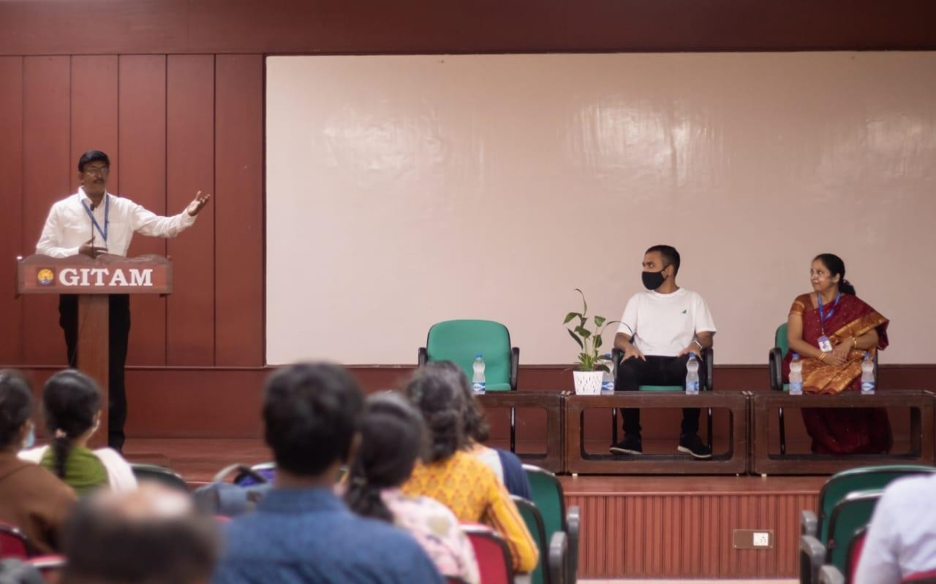

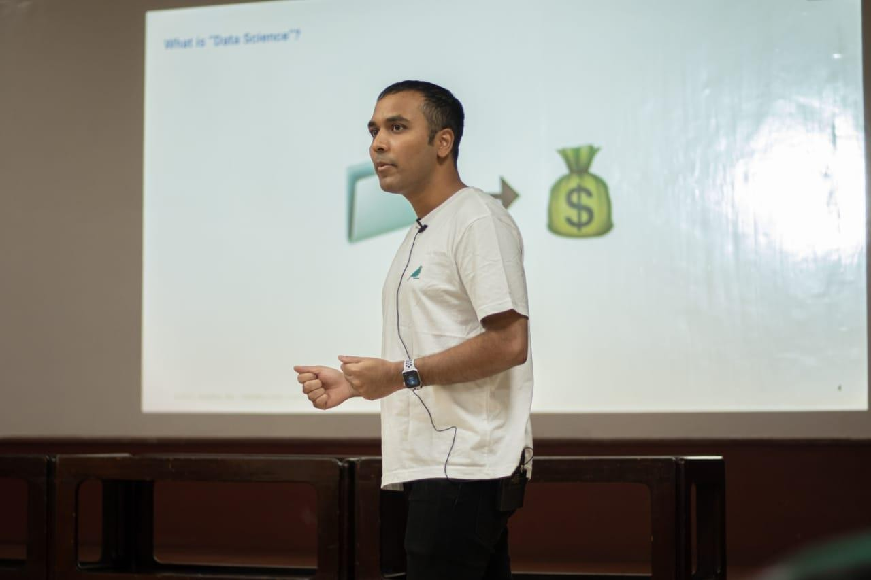



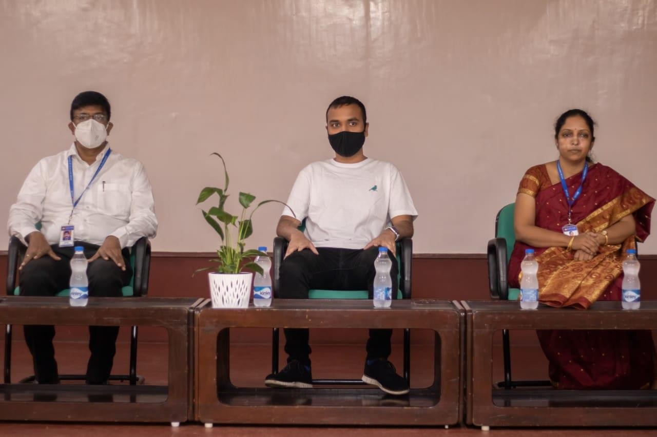

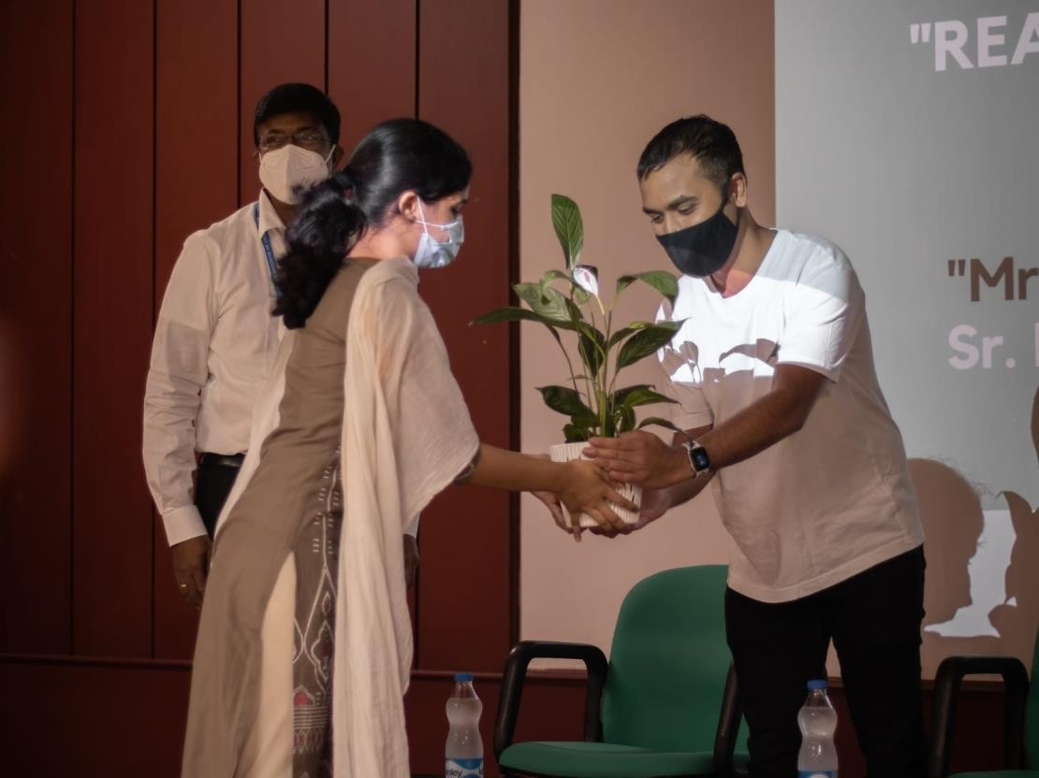





ACM, VISAKHAPATNAM

PARICHAY 2.0 – EVENT REPORT

# Event Snapshot

|  |  |
| --- | --- |
| **EVENT SNAPSHOT** | |
| Event Name: | Roots of Data Anatomization |
| Organizing Club: | ACM |
| Event Date: | 02/12/2021 |
| Event Time: | 11:00 AM to 1:00 PM |
| Event Mode / Venue: | Offline / Dr. B.R Ambedkar Auditorium |
| Social media reach: | Instagram: @gitam_acm  LinkedIn: https://[www.linkedin.com/company/acm](http://www.linkedin.com/company/acm)  -gitam-association-for-computing-  machinery/mycompany/ |
| Registrations: | 75 |
| Number of Participants/Attendees: | 70 |
| Winners (if any): Name - Regd ID - Email ID | NA |
| Faculty - Judge - Guest Speaker: | Mr. Krishna Vadakattu |
| Event Report Author - Designation: | Guru Charan - Event Manager Lead. Abhishek D. -Event Manager.  Sai Snehita K – Membership Chairperson. |